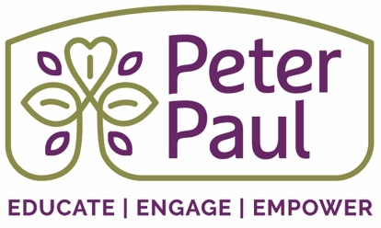

Family and Community Engagement Executive Board Updates
Prepared: 11/15/2021

Programs and Services | Overview: (current function and structure) | Highlights:
Promise Family Network (PFN) | Caregivers of current and prospective students of the Peter Paul youth program assist in creating a community focused on strengthening their family wellbeing as well as developing stronger relationships between caregivers, children, and other families. | - A current PFN participant has served as a referral source for several families to connect to Peter Paul and have meet with Sherika and Chimere consistently.  - Completed Fall programing on November 12th and the team has witnessed increased ownership of the activities by PFN participants.
Z-LIFE (Leading Individuals to Foundational Employment) | Z-LIFE provides access to living wage employment, entrepreneurial opportunities and wrap around support services to individuals 18-26 years old that reside in Richmond City. | - Assisted a 19-year-old ZLIFE participant, who moved into her first apartment this spring, maintain her housing when her roommate unexpectedly moved out without paying their portion of the rent. Peter Paul was able to cover the missed rent as well as assisted the participant with completing the rental assistance application.  - Two Z-LIFE participants are currently employed as program assistant with Peter Paul.  - Sam Brown left the position as the Workforce Barrier Navigator, effective 11/12/2021. Currently hiring for a Z-LIFE Program Coordinator, job listing available here.
Food Distribution | Bi-monthly food distribution occurs every 1st and 3rd Wednesday. | - Through a relationship with the Richmond City Health District (RCHD) Peter Paul can support providing food during Narcan distributions throughout the East End.
Immediate /Emergency Response Programs | Immediate and emergency response services are provided to current Peter Paul families as well as community members through partnerships with ACTS, The Giving Wall, CARITAS as well as Peter Paul’s immediate response budget. | - Connected a PFN family with CARITAS and covered the expenses to provide beds for the four children in the home.  - The Little Pantry in front of the Coleman Center has served as a hub for connecting with neighbors and establishing new relationships.

